Chú thích các câu lệnh select và database.
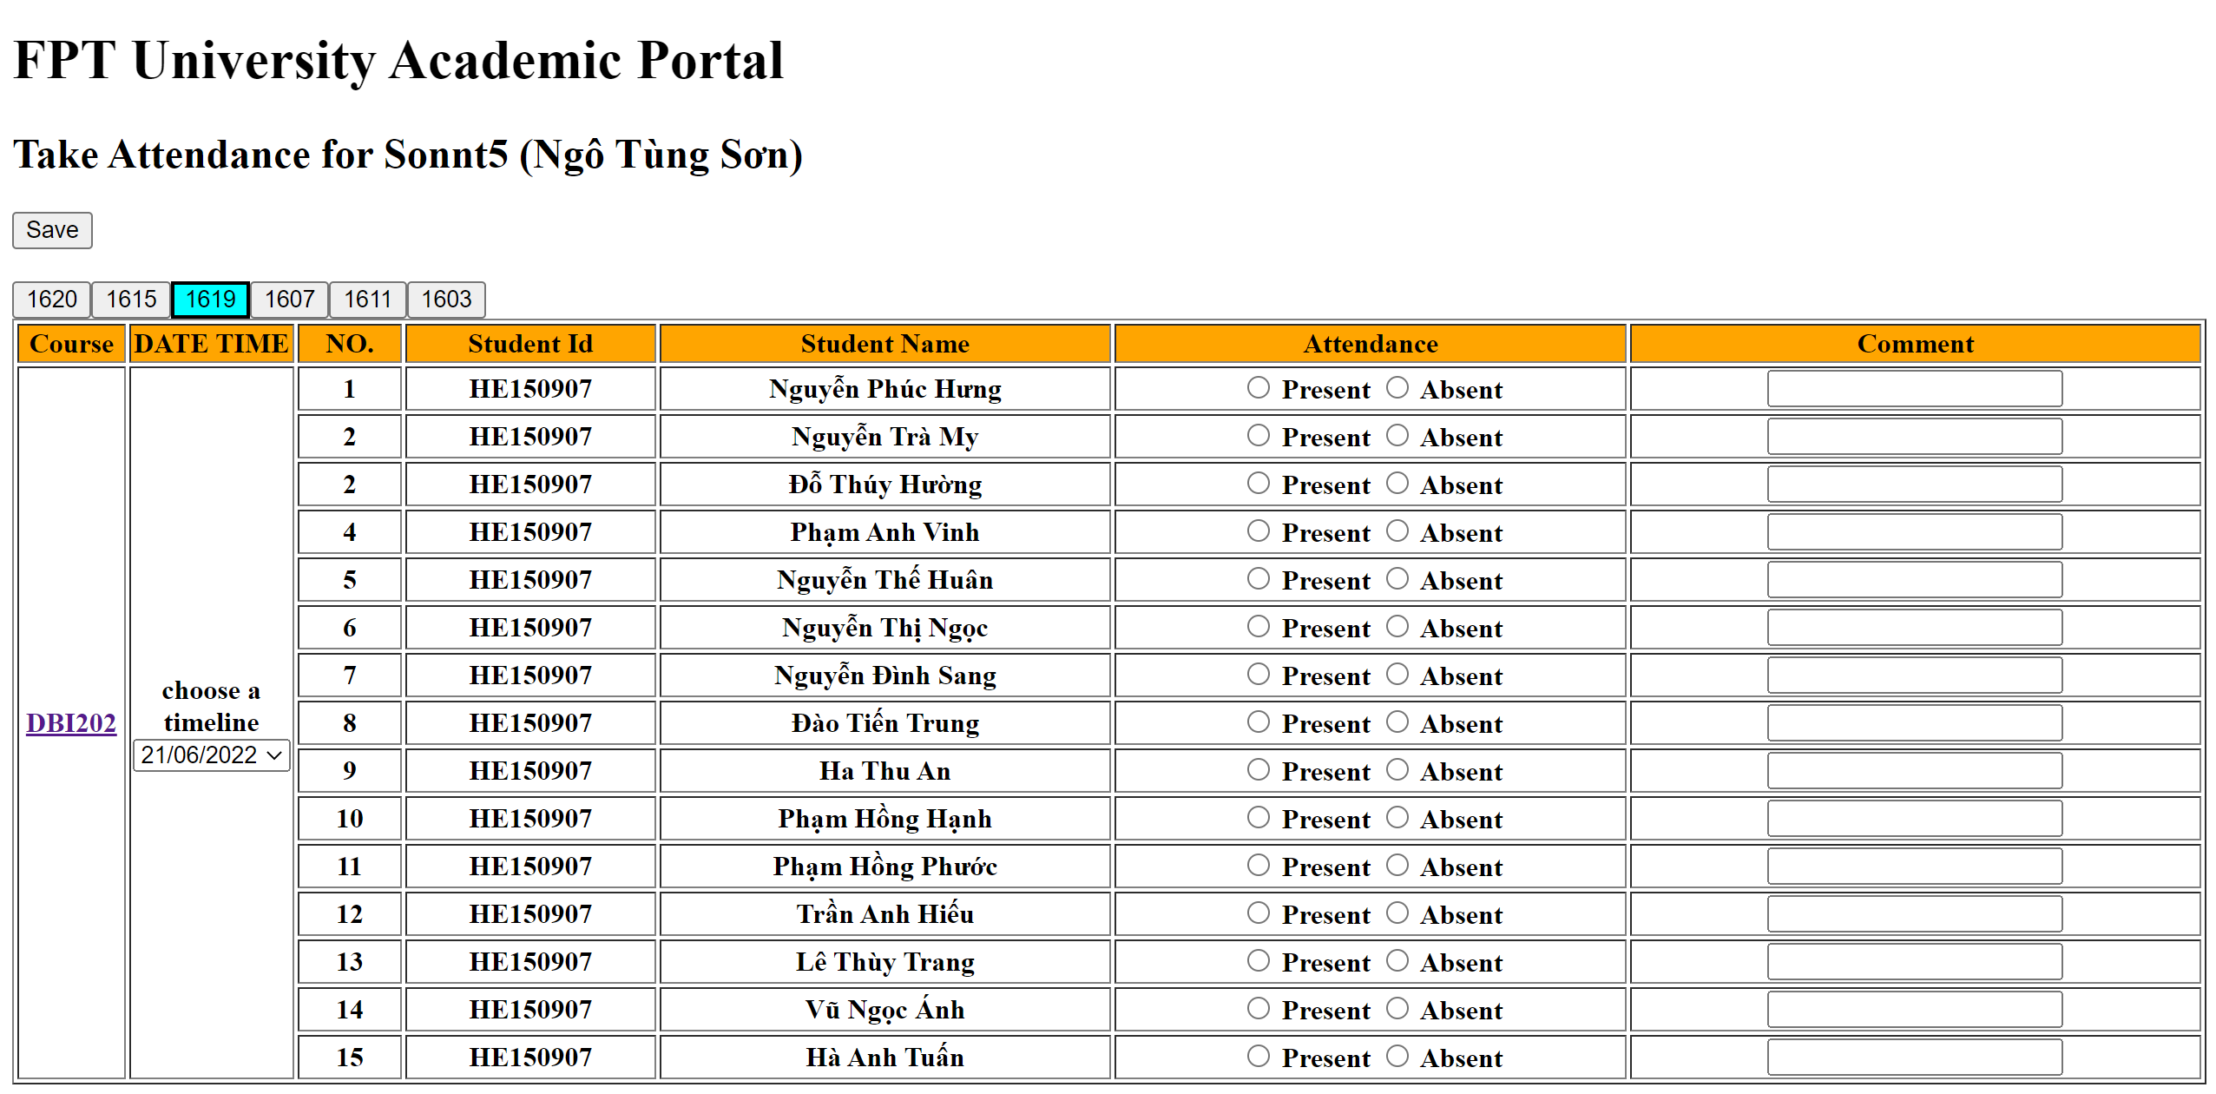

SELECT G.groupName, Sj.subjectCode, Ss.[sessionDate],S.rollNumber,S.fullName, Att.[status], Att.comment from [Group] as G
left join Enroll as E on E.groupId = G.groupId
left join Student as S on S.studentId=E.studentId
left join GroupSubject as GS on GS.groupId = G.groupId
left join [Subject] as Sj on Sj.subjectId = GS.subjectId
left join GroupSession as GSs on GSs.groupId = G.groupId
left join [Session] as Ss on Ss.sessionId = GSs.sessionId
left join Attendance as Att on Att.studentId = S.studentId
where SS.sessionDate = '2022-05-30' and Sj.subjectCode = 'PRJ301'

- Lấy groupName từ bảng Group, subjectCode từ bảng subject, sessionDate từ bảng Session, rollNumber & fullName từ bảng Student, status & comment từ bảng Attendance ,trả về danh sách học sinh vớI các thông tin trên theo ngày và mã môn học được truyền vào

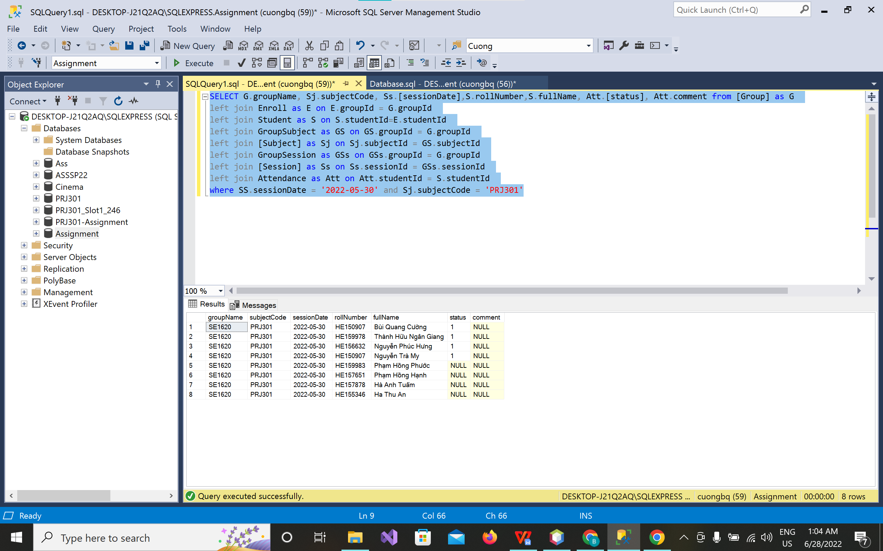

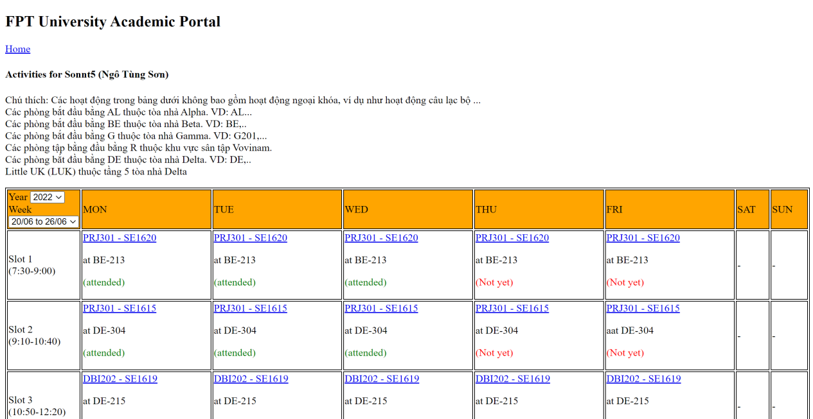

SELECT S.subjectCode, G.groupName, Sl.SlotName, R.roomName,At.[status], Ss.sessionDate from [Group] as G
left join [GroupSubject] as GS on GS.groupId = G.groupId
left join [Subject] as S on S.subjectId = GS.subjectId
left join GroupSlot as GSl on GSl.groupId = G.groupId
left join [Slot] as Sl on Sl.slotId = GSl.slotId
left join GroupRoom as GR on GR.groupId = G.groupId
left join Room as R on R.roomId = GR.roomId
left join GroupSession as GSs on GSs.groupId = G.groupId
left join [Session] as Ss on GSs.sessionId = Ss.sessionId
left join AttendSession as AtS on AtS.sessionId = Ss.sessionId
left join Attendance as At on At.attendId = AtS.attendId
left join Enroll as E on E.studentId = G.groupId
where E.studentId = 1 and Ss.sessionId between 1*7-6 and 1*7

- Lấy dữ liệu subjectCode từ bảng Subject, groupName từ bảng Group, slotName từ bảng Slot, roomName từ bảng Room, status từ bảng Attendance, sessDate từ bảng Session.
- ? thứ nhất là studentId của thằng mình vừa đăng nhập vào.
-? thứ hai là giá trị của week chọn trả về.

